Chicagoland Lionel Railroad Club first Open House with the NEW LAYOUT
Saturday September 17, 2016.

We have worked hard to get the track laid for this first Open House of the 2016-2017 season. The new layout has four levels of track. The lowest level is the Logging Route. The logging train starts out at the lowest level, rising up with a helix and switchback taking it to the lower main line. The rise is about 50 scale feet of height. There are two main lines that include a coal siding. Above this level is another pair of mainline tracks that wind around the full layout, including a large Drive-in Theater. We still support our Belt Line layout which is surrounded with a 120 foot background picture of Chicago, Lemont, Joliet refinery and power plant. This complements our refinery and power plant built on the layout. Of course we still have the Thomas layout upstairs.

Guests came in and were WOWED by our new layout.

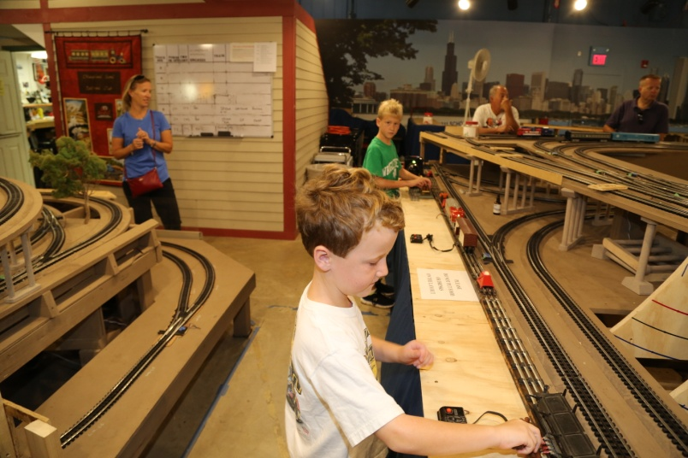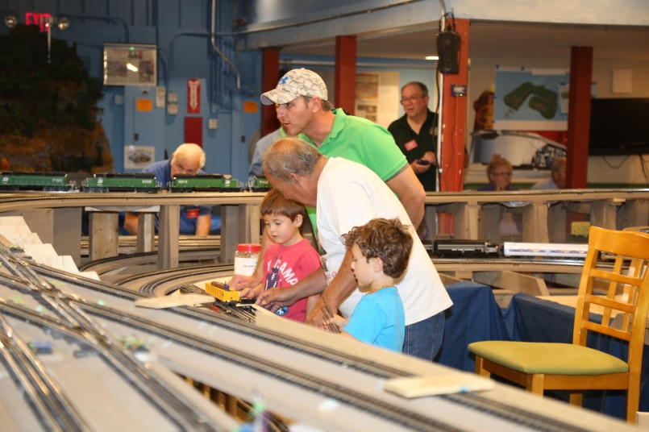
Connor and Logan run accessories as mom watches Mike, Colin, and Austin with CLRC member Bill

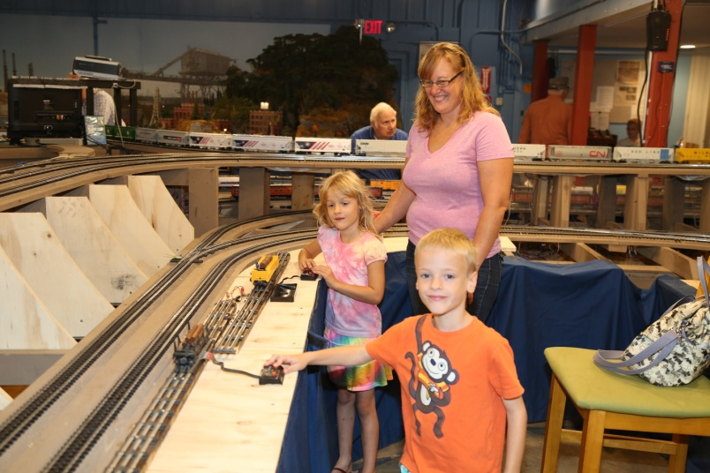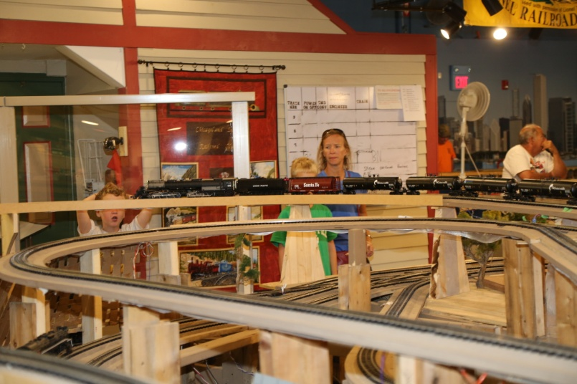
Amy, Effie and Gavin enjoy the accessories WOW can be heard as the Big Boy is on the top track

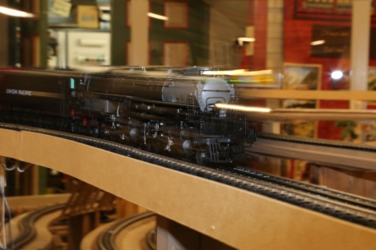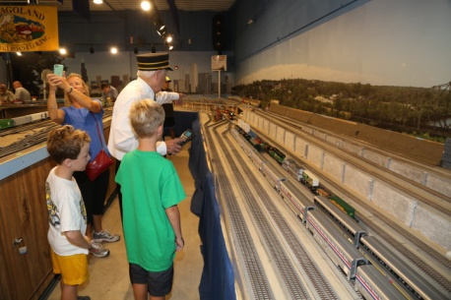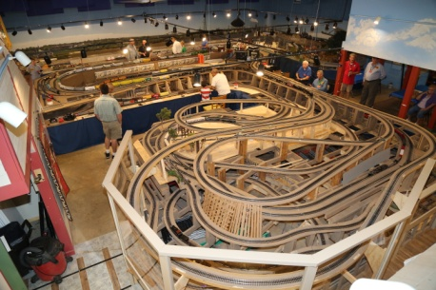
Big Boy streaking down the track Control instructions by Ron Corner view of the new Layout

