CLRC Layout – September 10, 2016 Herbert W. Koch

We are down to the wire. John Billone is putting the finishing touches on the final wiring to the Legacy/TMCC system. Trains are to be moving at our first Open House, September 17, 2016. Coal Trains, Freight Trains, Logging Trains, Passenger Trains, Intermodal Trains and much more will be running. This is our first year of a three year project. It took us over a year to design the layout. This last summer we made the bench work and laid the track. In the next few years we will continue to embellish the track plan, lay scenery, modify our industry with push button accessories and other improvements. We look forward to seeing our guests September 17, 2016 at our first Open House which will show our new layout at its beginnings.

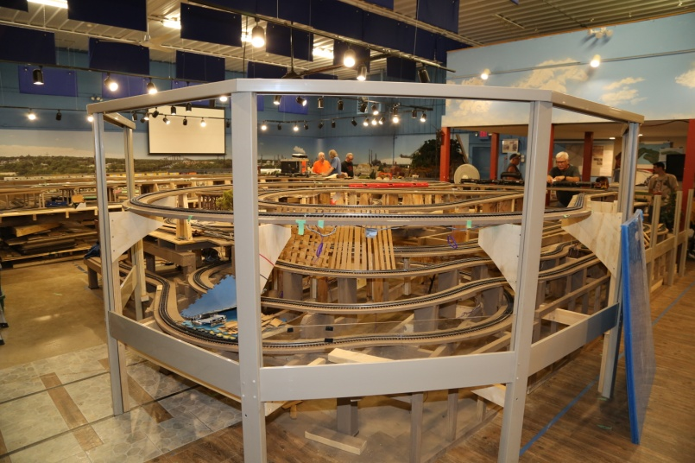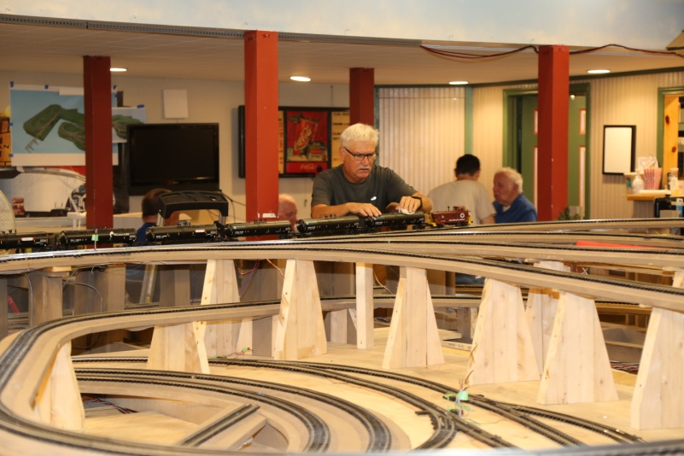
The Layout View as one walks in Joe is testing out layout with tanker cars

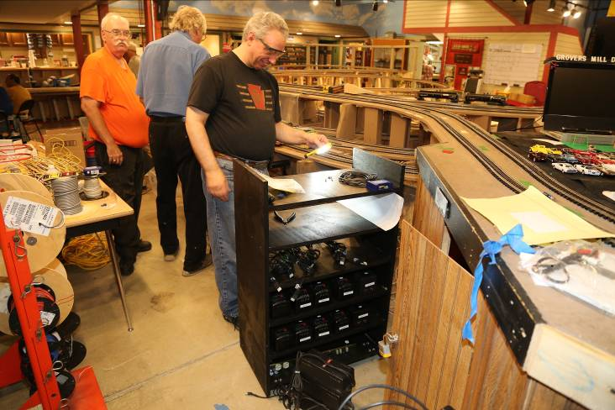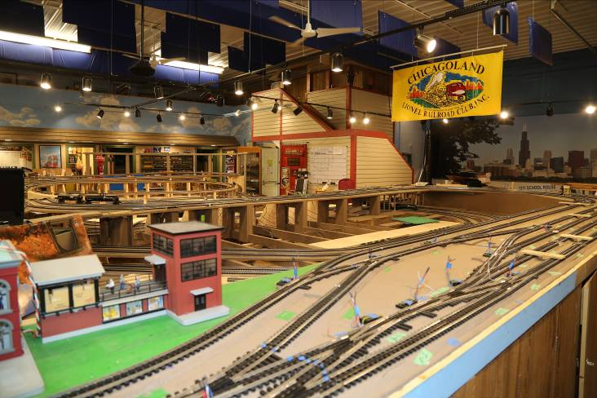
John finishes power and Legacy/TMCC controls Staging area to set up trains

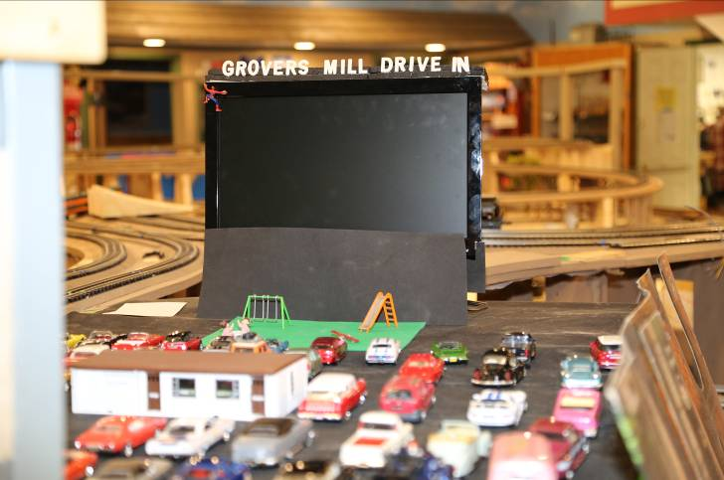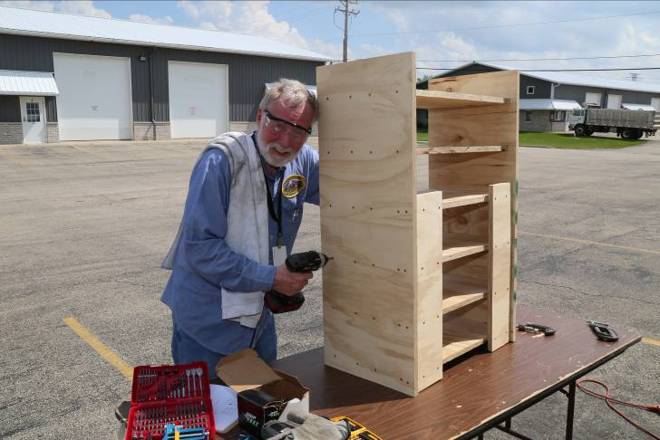
Grover Mill Drive In is OPEN Herb finishes up the Power Cabinet

